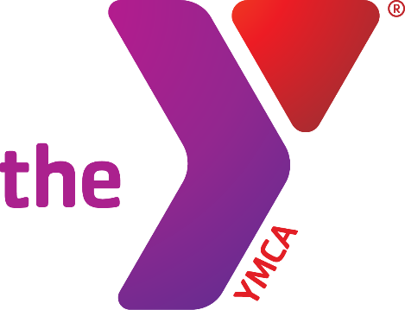Greater Monmouth YMCA



**HIGH SCHOOL**

**SWIM CLINICS**

Our 8 week clinic runs from the week of September 19 through the week of November 14. We provide an atmosphere offering a variety of impactful techniques and skill progressions that dramatically improve start, turn, and stroke techniques.

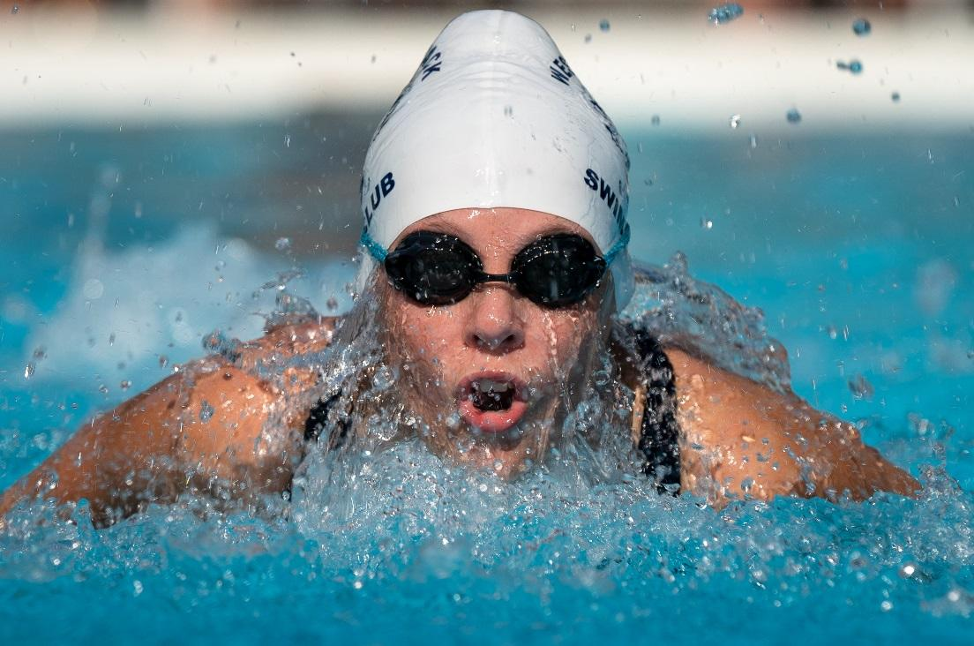 › Tuesdays | 7:30-8:30 p.m.

@ Old Bridge Family YMCA

1 Mannino Park Drive, Old Bridge, NJ 08857

› Fridays | 4:00 - 5:00 p.m.

@ Freehold Family YMCA

470 E Freehold Road, Freehold, NJ 07728

FEE: $250.00 for 8 weeks

REGISTRATION

Registration is required and space is limited. To register, visit ymcanj.org/GMNY-HS

For more information, contact Joan Truscio at [jtruscio@ymcanj.org](mailto:jtruscio@ymcanj.org)

